Free flow station with manually operated pneumatic path selection
Layout
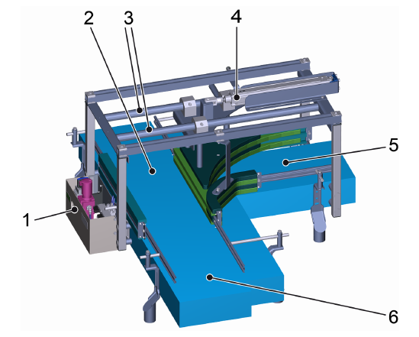
Figure 3-1: Free flow station with manually operated pneumatic switching function (the figure shows the variant with free flow to the right.)
Nº | Description | Nº | Description
1 | Pneumatic maintenance unit | 4 | Pneumatic cylinder
2 | Straight container outfeed | 5 | Container outfeed (free flow, right or left depending on the variant)
3 | Guide tubes of the rail bridge | 6 | Tank infeed

Function
The free flow station enables pneumatically adjustable path selection and includes operating controls (see chapter “Operation”, section “Operating controls”). The path must be changed manually on the corresponding operating controls.
The path depends on the status of the pneumatic cylinders:
- Pneumatic cylinder retracted:
Transport on the straight path
- Pneumatic cylinder extended:
Conveyor on the free flow path (right or left depending on the variant)

